Homework 2 Report

# Naïve Bayes Classifier

For the three given data sets(hw2_train/test, enron1_train/test, enron4_train/test), an accuracy displayed in the following picture was obtained.



The program is a straightforward Python implementation of the Multinomial Naïve Bayes classifier from the given link in the HW description.

# Logistic Regression

# Perceptron Algorithm

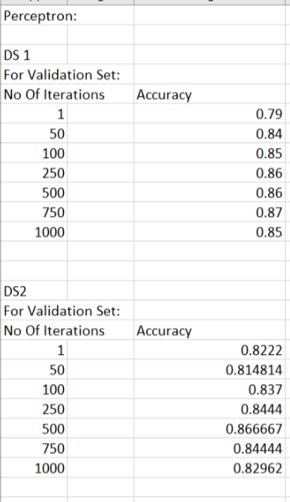For Perceptron algorithm, it was found that for approximately 750 iterations, the accuracy on the validation set is maximized. Results for all the 3 datasets are available in the Excel sheet in the Java Project folder and one can observe that the accuracy on the validation set tends to maximize around 750 iterations.

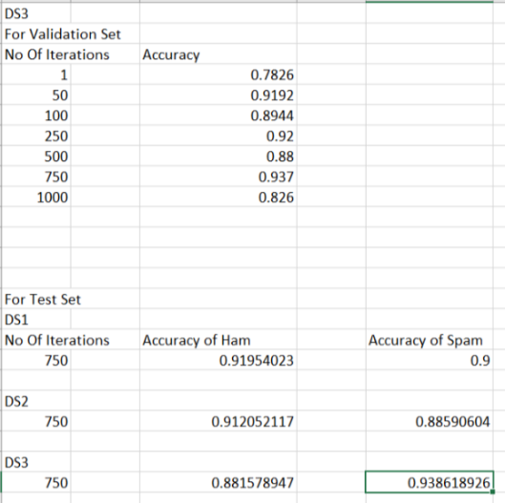

Validation was performed by training the Perceptron only on Training data and testing was performed by training the perceptron on both training and validation data.